Diversion Programs in the Criminal Justice System:
Models for Improvement and Reform

February 11, 2011
Intercontinental Hotel
New Orleans, Louisiana

This training program is sponsored by the
New Orleans Racial Justice Task Force

Jee Park, Racial Justice Task Force Facilitator
Special Litigation Counsel, Orleans Public Defenders

Task Force Members:
Judge Laurie White, Criminal District Court, Orleans Parish Criminal District Court
Chris Bowman, Communications Director, Orleans Parish District Attorney’s Office
Norris Henderson, Executive Director, V.O.T.E.
Rosana Cruz, Associate Director, V.O.T.E.
Marlon Defillo, Deputy Superintendent, New Orleans Police Department
Michael Bradley, Deputy Chief Defender, Orleans Public Defenders

This program is sponsored by the American Bar Association Criminal Justice Section with funding provided by the Bureau of Justice Assistance.
PRETRIAL DIVERSION
BENEFITS TO THE LOCAL CRIMINAL JUSTICE SYSTEM
PRESENTATION AGENDA
February 11, 2011
The Intercontinental Hotel
La Salle Ball Room

12:00 pm
Buffet Lunch (located outside the La Salle Ball Room)

12:30
Welcome and Program Overview
Cynthia Jones, Director,
ABA Racial Justice Improvement Project

Introductions
Jee Park, New Orleans Task Force Facilitator,

1:00-2:00
“Diversion Today” Presentation, Spurgeon Kennedy
Overview of national standards and best practices for criminal justice diversion programs

Break (refreshments provided)

2:15- 3:30
Model Diversion Programs Across The Country

Barbara R. Darbey, Executive Director of Pre Trial Services, Rochester New York

Anna M. Roberts-Smith, First Assistant Jessamine County Attorney, Criminal Prosecution Division Director, Nicholasville, Kentucky

Karen Galloway, Director of Pretrial Intervention, Fifth Judicial Circuit, Columbia, South Carolina

3:30-4:00
Audience Question and Answer

Presenters/Panelists

Spurgeon Kennedy – Mr. Kennedy is Director of the D.C. Pretrial Services Agency’s Office of Research, Analysis and Development. In that position, Mr. Kennedy helps lead the Agency’s strategic planning initiatives and efforts to implement evidence-based practices and innovations. Before joining the Pretrial Services Agency, Mr. Kennedy served as Programs Manager with the U.S. Department of Justice’s National Institute of Justice, overseeing the Institute’s Breaking the Cycle system-wide drug testing and treatment initiative, and helping to create and implement field tests, demonstration programs, and other applied research. Mr. Kennedy also served as a Senior Associate with the Pretrial Services Resource Center, a technical assistance provider to and national clearinghouse for information about pretrial services agencies and court processing and jail crowding issues.

During his nearly 30 years in the criminal justice field, Mr. Kennedy has provided technical assistance and support to organizations such as the Office of Justice Programs, the American Bar Association, the National Institute of Corrections, the Annie E. Casey Foundation and the Edna McConnell Clark Foundation. He also has served as a facilitator or training faculty member for agencies such as the National Association of Pretrial Services Agencies, the American Probation and Parole Association, the National Institute of Corrections, the National Institute of Justice, the Office on Violence Against Women, and state pretrial associations in Michigan, Ohio, Florida, Pennsylvania, and California.

In addition, Mr. Kennedy has authored or co-authored several criminal justice articles and publications, including: Charge Specialty and Re-victimization by Defendants Charged with Domestic Violence Offenses (National Institute of Corrections, Topics in Community Corrections, 2008); Pretrial Diversion in the 21st Century: A National Survey of Pretrial Diversion Programs (Bureau of Justice Assistance, forthcoming); Commercial Surety Bail: Assessing Its Role in the Pretrial Release and Detention Decision (Pretrial Services Resource Center: November 1996)

Barbara Darbey – Barbara is the Executive Director of Pre-Trial Services where she has worked since 1985. She holds a Masters Degree in Public Administration and served in a number of management positions with the agency before becoming the Executive Director in 2001. She co-authored an original research study of Pre-Trial Services Corporation’s Felony DWI Diversion Program in 1987 and has completed several follow up studies since that time. Barbara served for a number of years on the Board of the New York State Association of Pretrial Service Agencies, including a term as Vice President for Diversion. She was recently elected as Treasurer of the National Association of Pretrial Service Agencies Board. Barbara served on both of the NAPSA Release and Diversion Standards Revision Committees. Currently, Barbara serves on the NAPSA Diversion Committee and is the primary author for the 2008 revision of the Pretrial Diversion/Intervention Standards.

In addition, Barbara has worked with the National Institute of Corrections on the Pretrial Release training DVD and is trainer for the Pretrial Executive Development series. She was awarded NAPSA’s Member of the Year in 2005 and the New York Association of Pretrial Service Agencies’ Olgiati Award in 1998.

Anna Roberts Smith – Mrs. Roberts-Smith was born and raised in Lexington, Kentucky. She attended the University of Kentucky as a psychology major and later returned to the University of Kentucky where she obtained her law degree in 2003.

During her legal studies, Mrs. Roberts-Smith interned at the Fayette Commonwealth’s Attorney’s Office and it was there that her passion for prosecution emerged. She knew from that first year internship forward that she would be a prosecutor. Upon graduation, Mrs. Roberts-Smith found employment with the Jessamine County Attorney in the criminal prosecution division. She is a graduate of Leadership Jessamine County and still involved with the organization. She takes particular interest in events relative to Jessamine county and lends her support to various causes whenever she can. She attended the Kentucky Prosecutor’s Institute in 2004 sponsored by the Kentucky Attorney General’s Office and later that year was promoted to the Director of the Criminal Prosecution Division. In 2005, she represented the Jessamine County Attorney’s Office when approached by the District Court Judges to consider a Diversion Program and later that year the program was initiated. In 2007 she became the First Assistant Jessamine County Attorney and later that year was recognized by the Kentucky Bar Association for the high number of continuing education credits she earned. In 2008 she was nominated to be the Kentucky Assistant County Attorney of the Year and with the support of the District Judges, the elected County Attorney and Law Enforcement she won that title. That same year, she was part of the team that put together Jessamine County’s first misdemeanor Drug Court and is still an active member of that team.

Karen Galloway – Karen C. Galloway is the Director of the Fifth Circuit Solicitor’s Pretrial Intervention Programs (PTI). A lifelong resident of the Columbia area, she graduated from the University of South Carolina in 1973 and continued her education at USC and Brandeis University in Waltham, Massachusetts. She has been employed for the Solicitor of the Fifth Judicial Circuit for the last 36 years serving as the program director and responsible for the supervision of all program components. Her responsibilities include program development, case supervision and collection and accounting for all finances for program operation to include the Alcohol Education Program (AEP), the Traffic Education Program (TEP), the Juvenile Court Alternatives Program (JCAP) and the Pretrial programs in Richland and Kershaw counties. She has served as a member of the Lexington County Municipal Association, Columbia YMCA, President of the South Carolina Pretrial Intervention Programs, Board member of NAPSA, Chairman of Irmo Police Advisory Committee, and she was appointed by the Governor to serve as the Pretrial representative to the South Carolina Commission on Prosecution Commission, and she was the recipient of the Donald H. Holland Lifetime Leadership award from the South Carolina Pretrial Intervention Programs.

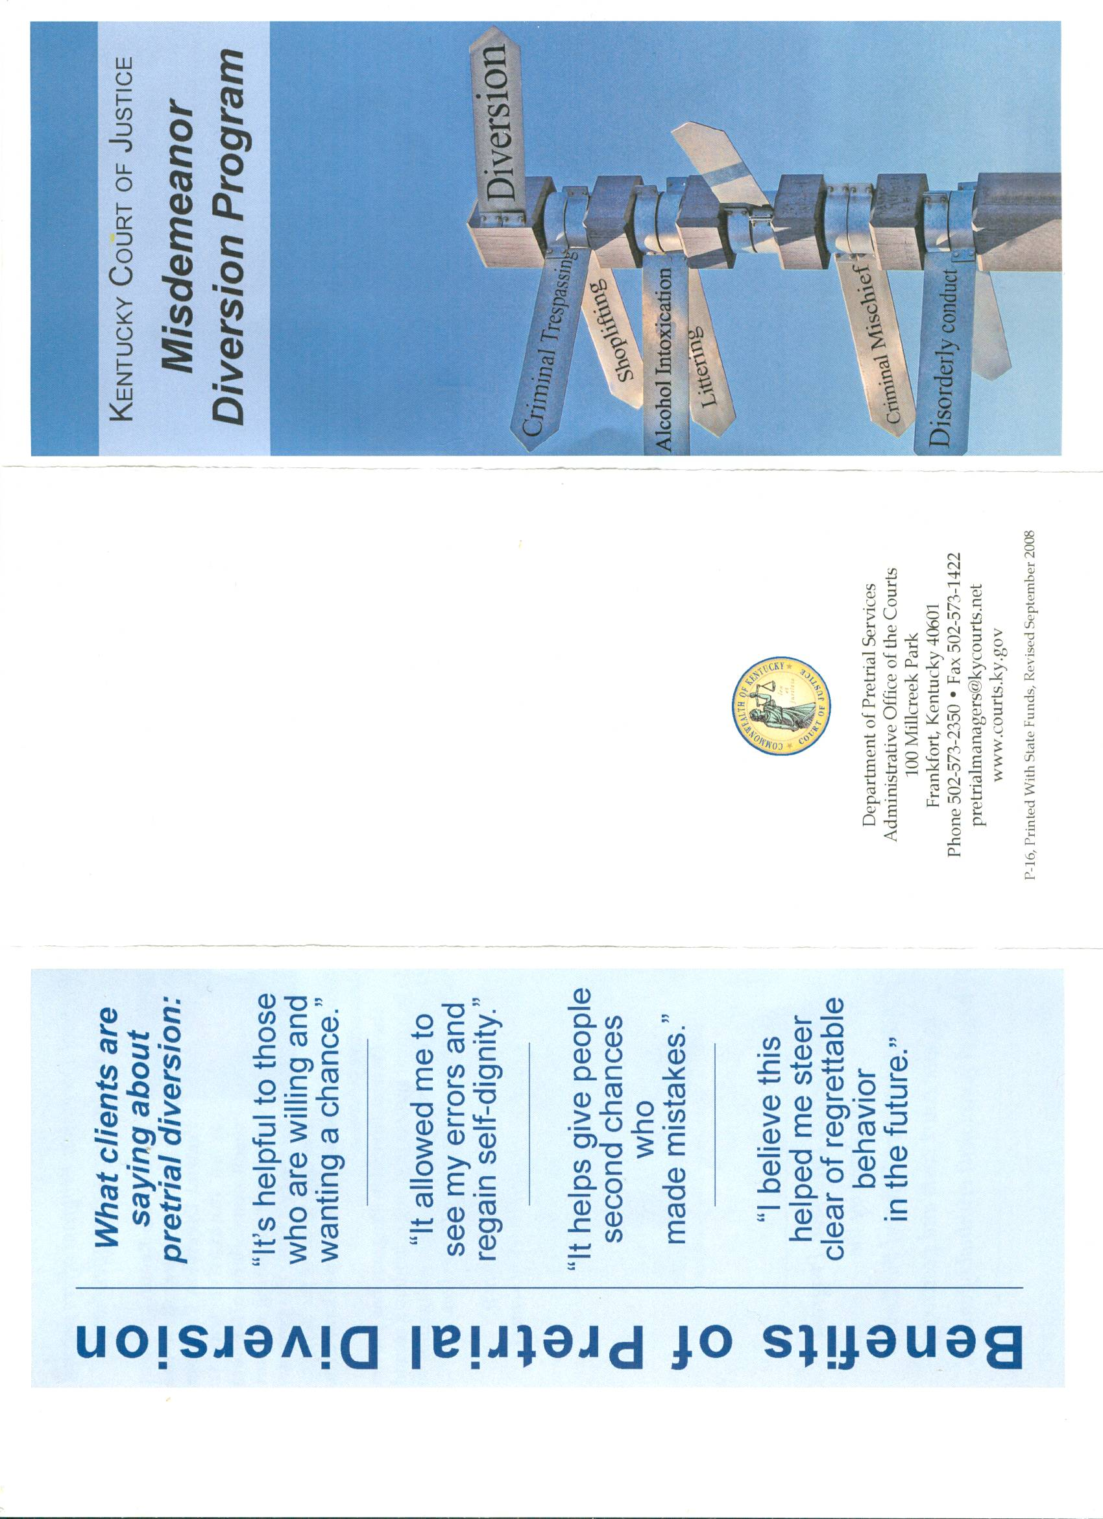

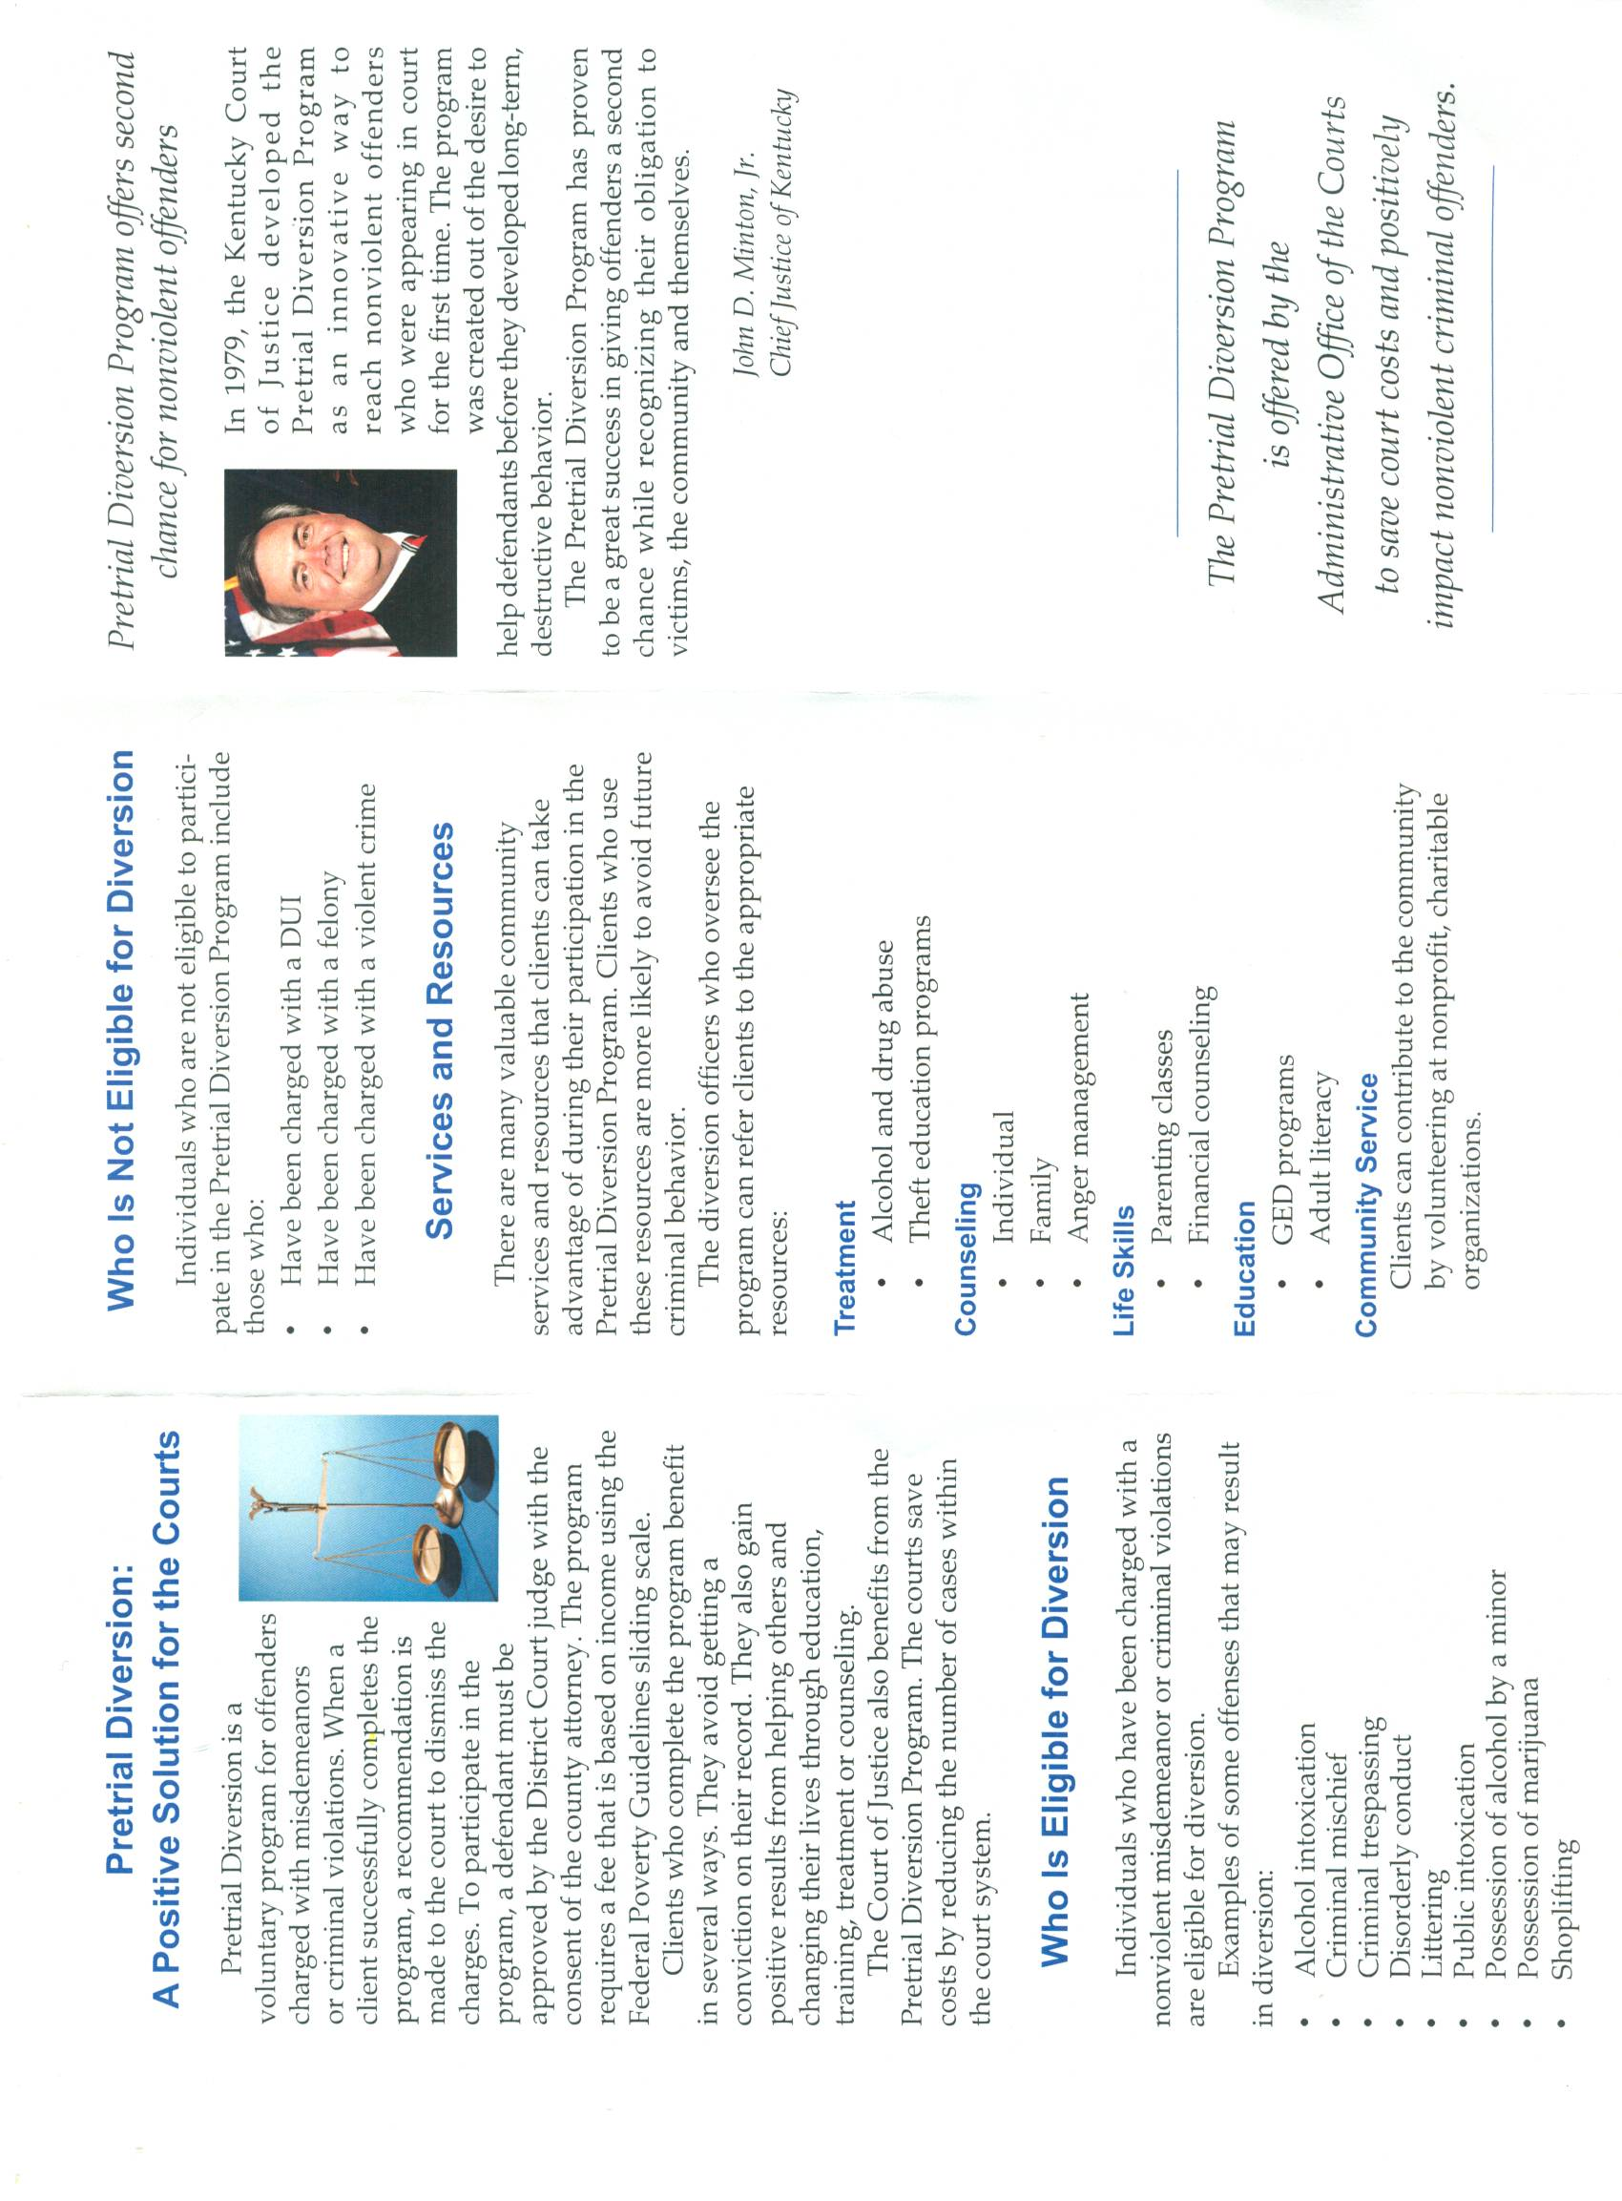

Pre Trial Services Corporation of the Monroe County Bar Association
80 West Main Street Suite 200 Rochester, New York 14614
http://www.monroepretrialservices.org/

TRADITIONAL PRE-TRIAL DIVERSION:
This is the original Diversion program created in 1974 to address the needs of defendants charged with a variety of crimes. As this is an adult program, clients must be over 16 years of age, be released from jail pending trial, and be willing to discuss the behavior which led to the arrest. The Diversion Counselors develop a performance contract based on the issues identified during a detailed intake process. By signing the contract, the client agrees to enter treatment to address these problems. The contract is then presented in court and, if all parties agree, the case is adjourned while the client completes the treatment program. The case remains open on the court docket with periodic appearances where the Diversion Counselor reports on the defendant’s compliance with the contract requirements. Satisfactory completion will result in a reduction or dismissal of the pending charges. The Diversion staff provides several types of group programs designed for specific populations which address the needs seen as critical for long term success.

FELONY DRIVING WHILE INTOXICATED DIVERSION:
This program, created in 1980, focuses specifically on intervention with defendants charged with a felony level DWI (second arrest for a Driving While intoxicated arrest within 10 years of a DWI conviction). Like the traditional Diversion Program, the Felony DWI Diversion is focused on treatment intervention. It differs from the other Diversion program, however, in several important ways. First, all clients referred to the DWI program must be screened by the District Attorney's DWI Bureau for suitability. Second, the actual diversion of the defendant is based on agreement that he/she will plead to a misdemeanor DWI in satisfaction of the felony only through successful completion of treatment, relinquishing the right to drive while in program, and making significant personal changes which support a sober lifestyle. By asking the court to hold up prosecution, the Felony DWI Program presents an option to intervene quickly and meaningfully with this multiple offender population.

Pretrial Intervention in South Carolina

PTI is a Diversionary Program designed for first-time offenders of non-violent crimes. This system allows the defendant to be diverted from court and enter into a program consisting of counseling, education, community service work, restitution, drug testing, and prison tours. Successful completion of the program requirements will allow the defendant’s arrest record to be expunged (destroyed). The goal of this program is to give first-time offenders a second chance. Offenders may participate in this program only one time. PTI is a self supporting program under control and supervision of the Office of the Solicitor, and is supported through cooperation of Judicial, Law Enforcement, and Community Service Agencies.

The PTI Act of 1980 states that PTI shall be appropriate where:
- Justice will be served by placing the offender in an intervention program.
- The needs of the offender and state will be better served outside the traditional criminal justice process.
- The offender poses no threat to the community.
- The offender is unlikely to be involved in further criminal activity.
- The offender is likely to respond quickly to rehabilitative treatment.
- The offender has no significant prior criminal history.
In order to gain access to the PTI program an application must be filed. The defendant will bring in the warrant or ticket, picture identification, social security card, and an application fee of $100.00 (money order). An interview will be conducted to gather information about the arrest and background information. The PTI staff will contact all parties involved in the case for recommendations. A complete criminal background check is conducted. The Office of the Solicitor makes the final decision regarding admission into the program. If the defendant is denied, the case is returned to court for full prosecution. If the defendant is approved, the case will be scheduled for orientation. The defendant will pay a participation fee of $250.00 (money order). The requirements for completion are assigned at this time. Upon successful completion, the Expungement Order for destruction of arrest records will be awarded. The defendant will pay an Expungement fee of $250.00 (money order) to the PTI office, as well as a $35 (money order) filing fee for the Clerk of Court. Both fees will be processed through the PTI office. If the defendant does not comply with the program requirements, the case will be returned to court for full prosecution.

The Racial Justice Improvement Project
The ABA’s Criminal Justice Section has established the Racial Justice Improvement Project pursuant to a grant from the Bureau of Justice Assistance. The ABA has chosen four jurisdictions-- St. Louis County, Minnesota; Wilmington, Delaware; Brooklyn, New York; and New Orleans, Louisiana-- to receive grant funds to implement local racial justice reforms. Jack Hanna, Director of the Criminal Justice Section, serves as grant director and Cynthia E. Jones, Law Professor at American University, serves as project director.If you’re interested in more information regarding this project, please contact ABA Criminal Justice Section attorney, Salma S. Safiedine at safiedis@staff.abanet.org or you can learn more about the Project at: http://www2.americanbar.org/sections/criminaljustice/Pages/racialjustice.aspx

The New Orleans Racial Justice Task Force
Through a grant from the Bureau of Justice Assistance, the ABA Criminal Justice Section has established the Racial Justice Improvement Project and has selected New Orleans, Louisiana as one of the four jurisdictions chosen to create a task force comprised of members of the community, and the top officials from the local police, judiciary, prosecution and defense. The goal of the task force is to identify a specific racial disparity in their criminal justice system then institute a specific policy reform to reduce or eliminate the disparity. This Task Force believes the criminal justice community would benefit much from an expanded and improved Diversion Program. Nationally, diversion programs have shown to be effective in reducing recidivism, local jail populations, and increasing judicial efficiency. Diversion programs offer defendants with alternatives to standard case processing through the criminal justice system with the goal of reducing the likelihood of further arrests through appropriate intervention based on thorough assessments of needs. There is currently one diversion program in New Orleans Parish run by the District Attorney’s Office. The Task Force is interested in either assisting in the expansion of this diversion program or creating an additional or supplemental diversion program to meet the needs of a population currently unmet by the existing diversion program.

Task Force Members

Jee Park
Special Litigation Counsel, Orleans Public Defenders
jpark@opdla.org

Jee Park is the Special Litigation Counsel at Orleans Public Defenders. After graduating from college, Jee worked at the Equal Justice Initiative (EJI) in Montgomery, Alabama, an organization that represents death row prisoners. Following EJI, she continued to work with indigent persons in the criminal justice system as a Prettyman Fellow at the Juvenile Justice Clinic at Georgetown Law Center, as a staff attorney at The Bronx Defenders, and as a Supervising Attorney at OPD prior to assuming her current position. Jee also served as a law clerk to Honorable Emmet G. Sullivan of the U.S. District Court for the District of Columbia. Ms. Park holds a B.A. in Government from Wesleyan University, a J.D. from the University of California, Berkeley (Boalt Hall), and an LL.M. from Georgetown Law Center.

The Hon. Laurie White
District Court Judge, Criminal District Court of Orleans Parish, Sec. A
sectiona@crimnalcourt.org

Honorable Laurie A. White is the presiding District Court Judge at Criminal District Court of Orleans Parish, Section A. She has jurisdiction over misdemeanor, felony and death penalty cases. Last year she oversaw twenty-six jury trials and eleven judge trials. She was elected in a city-wide election in November 2007 to fill a one year unexpired term, was unopposed in July 2008 and thus re-elected for a full 6-year term. Before her election, White practiced in state and federal courts throughout Louisiana for approximately twenty years. She also is admitted to practice before the United States Supreme Court and licensed in the State of Texas.

Judge White began her career as a prosecutor in Orleans and East Baton Rouge Parishes. She then worked as a City Attorney defending the New Orleans Police Department in false arrest and brutality claims, as well as defending the City of New Orleans in general civil litigation matters. She further practiced in the civil realm as an insurance defense attorney and handled plaintiff lawsuits and domestic issues during her legal career.

Judge White ran a successful criminal defense firm for fifteen years, managing numerous attorneys and staff while handling sex crimes, drugs violations and murder allegations, including the successful defense of clients facing the death penalty. She was counsel for a client released through DNA exoneration after seventeen years in prison for rape. This was the first such release after Louisiana law provided for DNA testing and exoneration. As an attorney, White’s greatest success resulted from criminal post-conviction matters in which numerous convictions were overturned for Brady evidence violations. Judge White has been certified with the National Board of Trial Attorneys (NBTA) as a criminal trial specialist since 2004. She is the past president of the Louisiana Association of Criminal Defense Lawyers (LACDL), and is a regular continuing legal education presenter. She also participates with the National Institute of Trial Attorneys (NITA) training law students and lawyers in trial persuasion techniques.

Christopher Bowman
Special Assistant to the DA, Communications Director
Orleans Parish District Attorney
cbowman@orleansda.com

Christopher Bowman is an Assistant District Attorney and Special Assistant to Orleans Parish District Attorney Leon A. Cannizzaro, Jr. In that capacity, he manages communications for the office and policies not directly related to public safety. He has assisted District Attorney Cannizzaro in the implementation of several progressive reforms of the criminal justice system in Orleans Parish. Prior to coming to the District Attorney’s office, Christopher practiced law in St. Louis and New Orleans focusing primarily in the area of corporate restructuring. In New Orleans, he has managed several successful legislative and judicial races. Mr. Bowman earned a BA in American Government from the University of Virginia and a JD from Loyola University where he served on the Law Review. Mr. Bowman is licensed to practice law in the states of Louisiana and Missouri.

Michael Bradley
Deputy Chief Public Defender, Orleans Public Defenders
mbradley@opdla.org

Michael D. Bradley is the Deputy Chief Defender at Orleans Public Defenders. Michael’s passion for indigent criminal defense was ignited in law school as a participant in Georgetown’s Criminal Justice Clinic. Upon graduation, Michael worked as a Public Defender at the Defender Association of Philadelphia. Michael later worked at the Bronx Defenders as a Senior Trial Attorney. Michael also served as a full-time judicial clerk in Bronx County prior to assuming his current position at OPD.

Mr. Bradley holds a B.A. in Legal Studies from the University of California, Berkeley, and a J.D. from Georgetown University Law Center.

Rosana Cruz
Associate Director, V.O.T.E (Voice of the Ex-Offender)
rosana@vote-nola.org
Rosana Cruz is the Associate Director of V.O.T.E (Voice of the Ex-Offender). Rosana came to VOTE from her position as Co-Director of Safe Streets/Strong Communities. Previously Rosana worked with the National Immigration Law Center helping to create the New Orleans Worker Center for Racial Justice and working to address the devastating impact of Hurricane Katrina on immigrants and refugees. Prior to joining NILC, she worked with SEIU in Miami, after having been displaced from New Orleans by Hurricane Katrina. Before the storm, Rosana worked for a diverse range of community organizations, including the Latin American Library, Hispanic Apostolate, the Lesbian and Gay Community Center of New Orleans, and People's Youth Freedom School. Ms. Cruz came to New Orleans through her work with the Southern Regional Office of Amnesty International in Atlanta. Ms. Cruz holds a BA in Race and Gender Studies from New College of Florida and is completing a Master of Arts program in Latin American Studies at Tulane University.
Marlon Defillo
Deputy Superintendent, New Orleans Police Department
jevarnado@cityofno.com

Marlon Defillo is the Deputy Superintendent of the New Orleans Police Department. Beginning his career as a “beat officer” in 1981, he has spent 29 years serving the New Orleans Police Department in a number of positions. In the 1990’s he rose through the positions of Sergeant, Lieutenant, and was eventually appointed as the Commander to the Office of Public Affairs - acting as the police department's official spokesperson and liaison to the news media. In 2005, as a Captain, he was appointed to Deputy Superintendent and assumed command of the Public Integrity Bureau (Internal Affairs Division). His responsibilities included internal administrative and criminal investigations of police officers accused of misconduct, monitoring the Department's Early Warning System, establishing integrity checks to monitor officers’ behavior, and tracking disciplinary cases through the appeals process. In August of 2007, he was appointed to the second highest position in the police department, and as Chief of Detectives, he became responsible for specialized investigations concerning crimes against persons (homicide, rape, child abuse etc) and those crimes against property (fraud, auto theft, etc). In June of 2010, Deputy Superintendent Defillo assumed command of the Field Operations Bureau and is currently responsible for the supervision of all uniform police officers who patrol and answer citizen calls for service and represents 72 % of commissioned personnel. Mr. Defillo holds a Bachelors and Master's Degree and is currently on the faculty at Southern University at New Orleans. He is a graduate of the FBI National Academy, session 197th, and a graduate of the Senior Management Institute for Police Executives at Harvard University.

